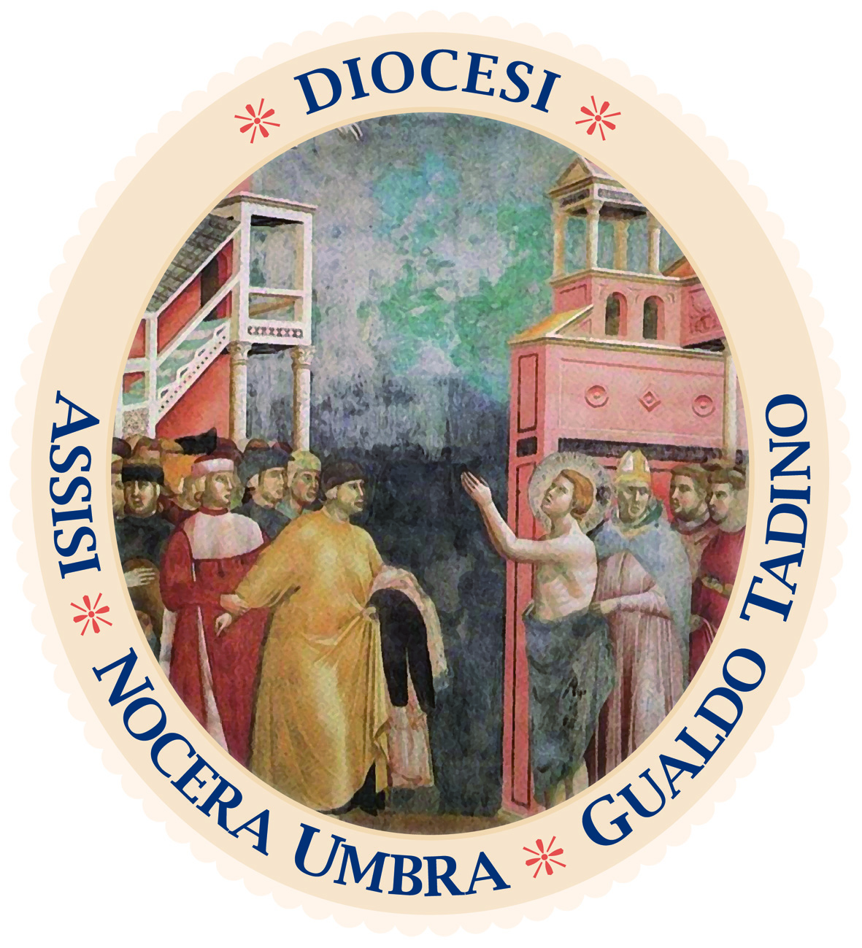
Diocesi di Assisi - Nocera Umbra - Gualdo Tadino
Curia diocesana

Ufficio Stampa

COMUNICATO STAMPA

ASSISI IN THE UNITED STATES WITH THE MUSEUM OF MEMORY

The exhibition, dedicated to saving 300 Jews, will be hosted in key Catholic schools on Long Island

ASSISI – The Museum of Memory, Assisi 1943-1944, continues its journey to the United States. Last year’s mission to the USA is bearing fruit because the exhibition in Italian and English, which tells of the 300 Jews saved in the seraphic city during the Second World War, will be exhibited in the main Catholic schools on Long Island. “Thanks to the collaboration with Pave the Way Foundation and DeSales Media, and the mission to the States last August of our responsible for international relations, monsignor Anthony Figueiredo – explains the director of the Museum, Marina Rosati – a series of collaborative ventures has been activated, in particular with the body equivalent to our regional school office, to make known this extraordinary page of hospitality. During the terrible years of the Shoah, there were also rays of light and the story of Assisi is one of these. We are proud that the city, its history, its heritage of values can be known even more, beyond the immense legacy of Saint Francis. Moreover – adds Rosati – the fact that all the material is also in Italian is a way to spread and popularize our language and culture. It is no coincidence that for the entire month of May 2022, the Museum was hosted at the Italian Cultural Institute in New York, attracting tangible interest”. After the parish of St Rose of Lima, (Massapequa) and the Saint Anthony’s HS, (Melville), the Museum will be in the St. John the Baptist DHS, (West Islip) and in Kellenberg Memorial High School (Uniondale). “We are pleased that the Museum can be visited by students – says Monsignor Figueiredo – especially in this moment in which the history of Assisi, of the Jews welcomed and saved, is more relevant than ever and must be a lesson in this dramatic moment for the Holy Land”.

Assisi, 14 novembre 2023

